Guest Sessions by Alumni

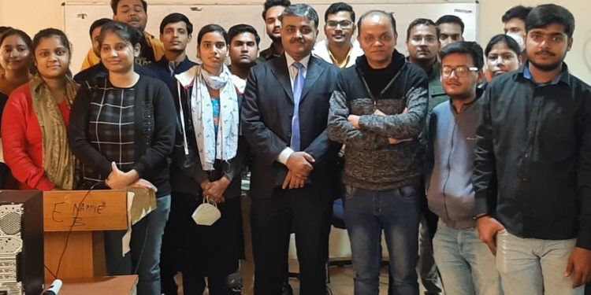
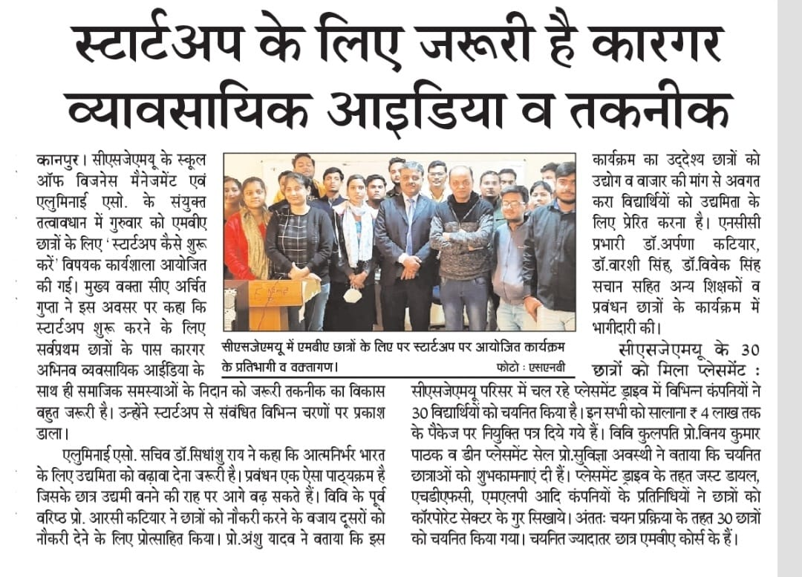
Translated Version
December 2, 2021, Kanpur – Today, under the aegis of Chhatrapati Shahuji Maharaj University's School of Business Management and Alumni Association , a workshop was organized for MBA students on how to start a startup, but the workshop was inaugurated by Director Professor Anshu Yadav, Keynote Speaker CA Archit Gupta, Former Director Professor RC Katiyar Alumni Association Secretary Dr. Sudhanshu Rai and Dr. Arpana Katiyar. Director Prof. Anshu Yadav said that it is always our department's endeavor to provide classroom education to the students as well as establish dialogue with industry experts so that they can compete in the market. Be aware of demand.
Keynote speaker CA Archit Gupta said that if students want to start a startup then they must have an idea first. Business should spread rapidly as well as that business can also provide employment to others. He highlighted every single point from the first step to the last step to start a startup. Alumni Association Secretary Dr. Sudhanshu Rai said that today self-reliant India has become Entrepreneurship has to be promoted and management is one of the courses whose students are best suited to become entrepreneurs. Former Director Professor RC Katiyar said that today's era is of entrepreneurship and we have to become job givers and not job takers. Lu NCC incharge Dr. Arpana Katiyar encouraged the students towards entrepreneurship. She welcomed and conducted the guests. Dr. Sudhanshu Rai did it but on this occasion Dr. Warshi Singh Dr. Vivek Singh Sachan along with teachers and management students were present.

Meet the Alumni Drive by Alumni Association of Chhatrapati Shahuji Maharaj University

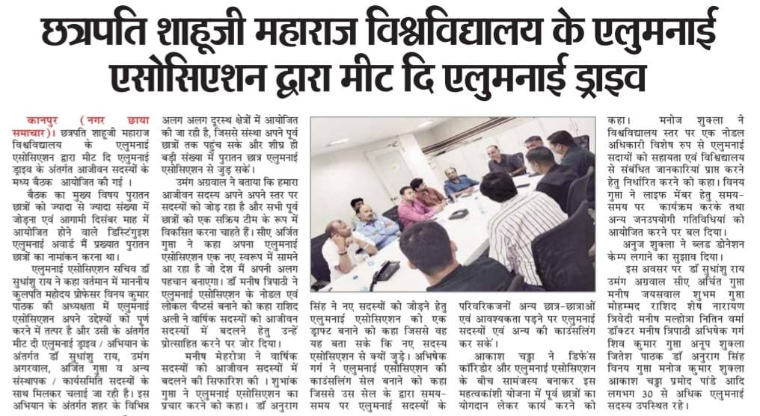

Translated Version

Kanpur (Nagar Chhaya News) 1 Alumni Association of Chhatrapati Shahuji Maharaj University organized a meeting among the life members under the Meet the Alumni Drive.
The main topic of the meeting was to connect the alumni in maximum numbers and to nominate eminent alumni for the Distinguished Alumni Award to be held in the coming month of December.
Alumni Association Secretary Dr. Sudhanshu Rai said that at present, under the chairmanship of Honorable Professor Vinay Kumar Pathak, the Alumni Association is ready to fulfill its objectives and under the Madina campaign, Ram, Umang Agarwal, Ajit and others are being run together. Under this campaign, various working committee members
It is being organized in different remote areas, so that the institution can reach out to its alumni and soon a large number of old students can join the Alumni Association.
Umang Agarwal told that our life member is adding members at their own level and want to develop all alumni as an active team. CA Arjit Gupta said that our Alumni Association is emerging in a new form which will create its own identity in the country. Dr. Manish Tripathi asked to form nodal and local chapters of Alumni Association. Rashid Ali stressed on encouraging them to convert annual members into life members.
It asked the Alumni Association to form a counseling cell, recommended to convert the members into life members, through which the cell asked to campaign from time to time.
The Alumni Association was asked to prepare a draft to indicate that new members could join.

